**Step 1 :**

User will create the excel file with all the details to create the formula.

Below is the excel format :

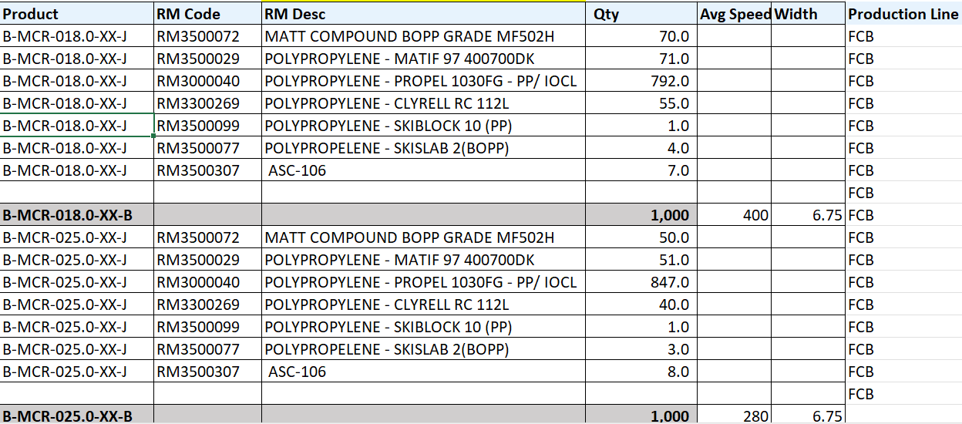

**Step 2:**

User will upload this excel file using the new created form

XXFIL Custom Responsibility >> Cash Management Super User >> FIL BOM Upload Data

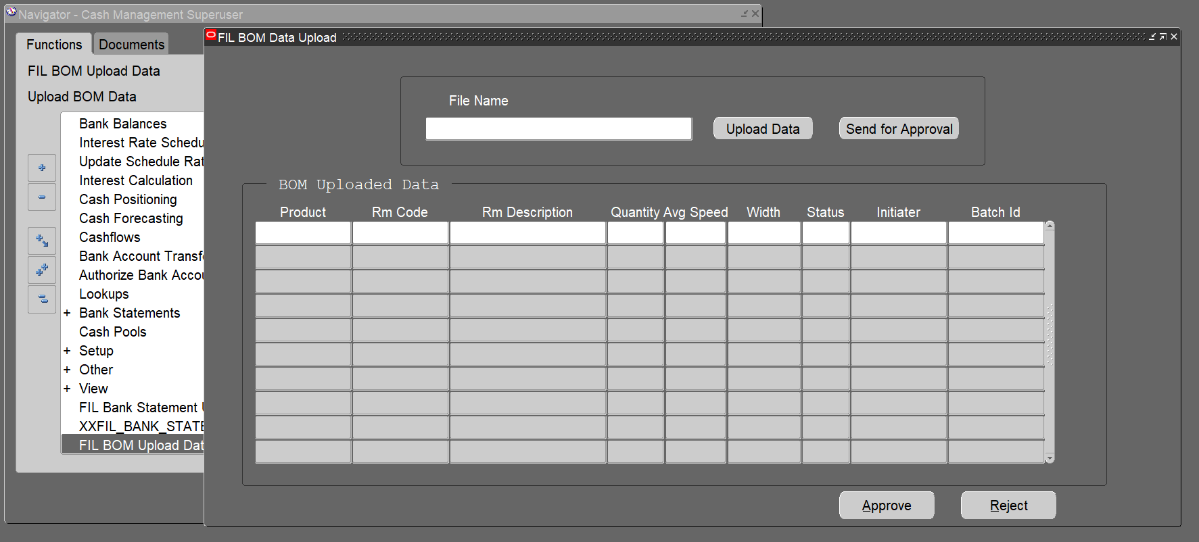

**Step 3:**

Click Upload Data

It will Open a browser window to upload file.

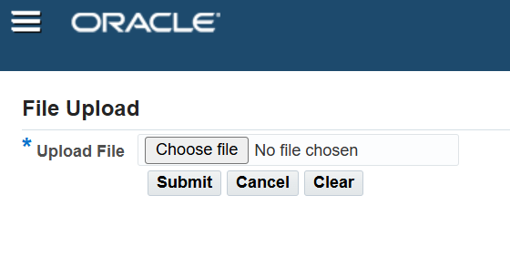

**Step 4 :**

Choose file and click on Submit button .

After submitting the data file , the data stored in a staging table and show in the form.

Uploaded file name automatically populate on the File Name field.

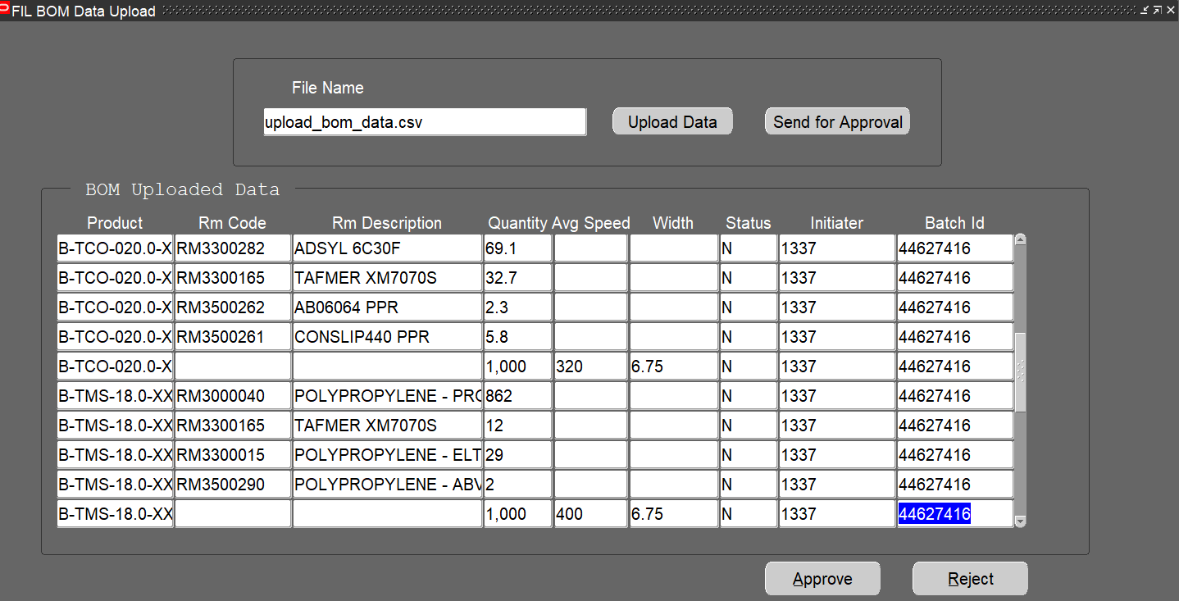

**Step 5 :**

Click on the Send for Approval button

It will send an email notification to the manager attached with the data file.

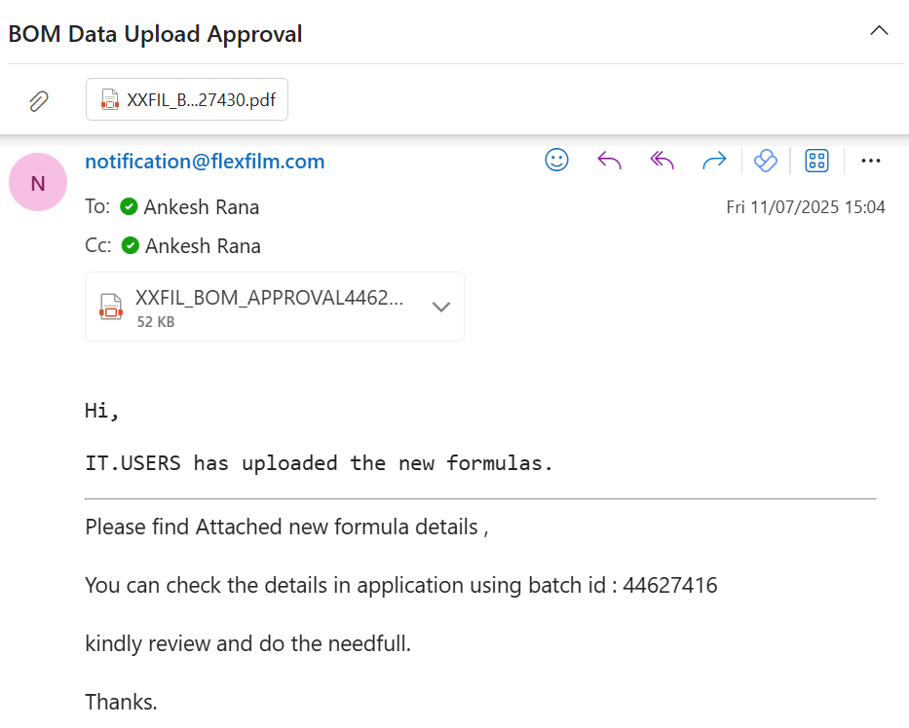  
Once approved the formula will be created and can be searched as below :

Formulator >> Formulas

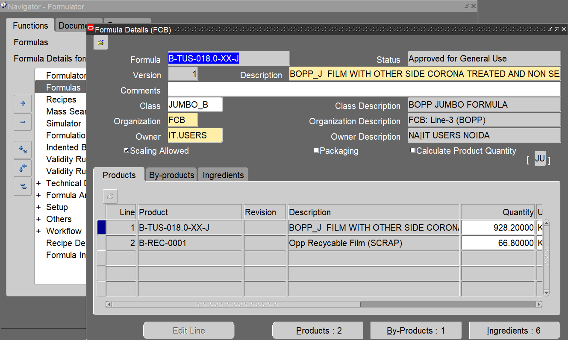

The approver will take the action either to approve or reject formula .

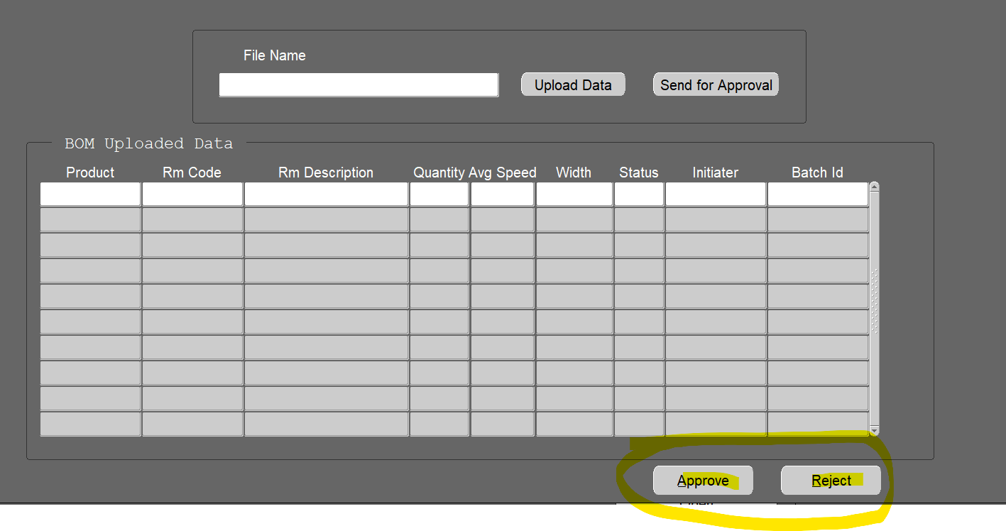

When you click on the approve or reject button it will open dialog box and show two options as shown below:

